# Team Name:

# Application - Online Store (as suggested in the slides)

Domain - Travel and tourism.

# Queries:

### Customers

1. Booking flights: Customers are able to book flights
2. Booking buses: Customers are able to book buses
3. Booking hotel: Customers are able to book hotels
4. Deciding itinerary: Customers can decide on a complete itinerary which includes flight/bus booking as well as being able to book a hotel room.
5. Planning a budget/time-constrained trip: If the customer provides a budget or a specific time window, the best optimal trip would be recommended to them based on these parameters.
6. Places to visit: The customer can see popular spots to visit during their trip
7. Dates recommendation: If the trip costs more to a customer than his/her budget, another set of nearby dates would be recommended if it costs less.

### Airline

1. Add flights: Airlines can add details of flights to this table.
2. Update flights: Airlines can update the details of pre-existing flights to this table.
3. Delete flights: Airlines can remove flights from the table.
4. Deciding the number of flights on the basis of trending destination: Airlines can query flight details based on trending destinations to manage the number of flights to a particular destination.
5. Deciding the fare on the basis of trending destination: Airlines can query for flight details based on trending destinations to decide fair of flights to a particular destination.
6. Offers: Airlines can provide attractive offers to customers who are using their services regularly.
7. Leg Space/ Priority Luggage/ Meals - Once they know the customer base for a particular flight, airlines can offer these services too.

### 

### Bus

1. Add bus routes: Bus service providers can add details of new bus routes to the table
2. Update bus routes: Bus service providers can update the details of pre-existing bus routes to the table.
3. Delete bus route: Bus service providers can remove bus routes from the table.
4. Deciding the number of bus routes on the basis of trending destination
5. Deciding the fare on the basis of trending destination
6. Offers: Bus service providers can provide attractive offers to customers who are using their services regularly.
7. Leg Space/ Priority Luggage/ Meals: Once they know the customer base for a particular route, bus service providers can offer these services too.

### Hotel

1. Add hotel: Hotel owners can add details of any new hotels they establish.
2. Update hotel(s): Hotel owners can update details of any pre-existing hotels.
3. Delete hotel: Hotel owners can delete any hotels that are not in use or being destroyed/sold etc.
4. Offers: Hotel owners can provide attractive offers to customers who are using their services regularly.
5. Deciding pricing of room to maximize the profit: Hotel owners can decide the price of the room based on the popularity of the room and other such parameters.
6. Major announcements: Hotel owners can issue any announcements to be made such as maintenance, fumigation, etc.

Director

1. Offers
2. Monitoring the database
3. Building Connection (Depending on the number of travelers, increasing its reach to other airlines and hotel)
4. Updating Permission

Innovation

1. Recommending places to visit at a destination - As the customer books, a flight or a bus for a particular destination, the places to visit would automatically be shown.
2. Deciding the complete itinerary - The customers are provided an option to plan out the complete itinerary based on certain inputs such as destination, start date, end date, number of persons, budget, etc. We are also planning to keep an option for train traveling in the itinerary if that plans out well in the budget of the customer.
3. Recommending the dates - If the trip costs more to a customer than his/her budget, another set of nearby dates would be recommended if it costs less.
4. Advertising hotel on the basis of bookings - Whenever a customer books a flight or a bus, the nearby hotels to the airport or the bus station would be automatically recommended.

## 

### Roles of Team Members:

Aarish: Designing the Database Schema

Kartik: Designing the Database Schema

Priyanshi: Identifying the stakeholders and the use cases for them

Vipul: Identifying the constraints and the relationship between data entities

Manan: Identifying the stakeholders and the use cases for them

## Data entities:

1. Customer
2. Airline
3. Bus
4. Hotel
5. Flight Information
6. Room Information
7. Bus Information
8. Room Facilities
9. Flight Booking
10. Room Booking
11. Bus Booking

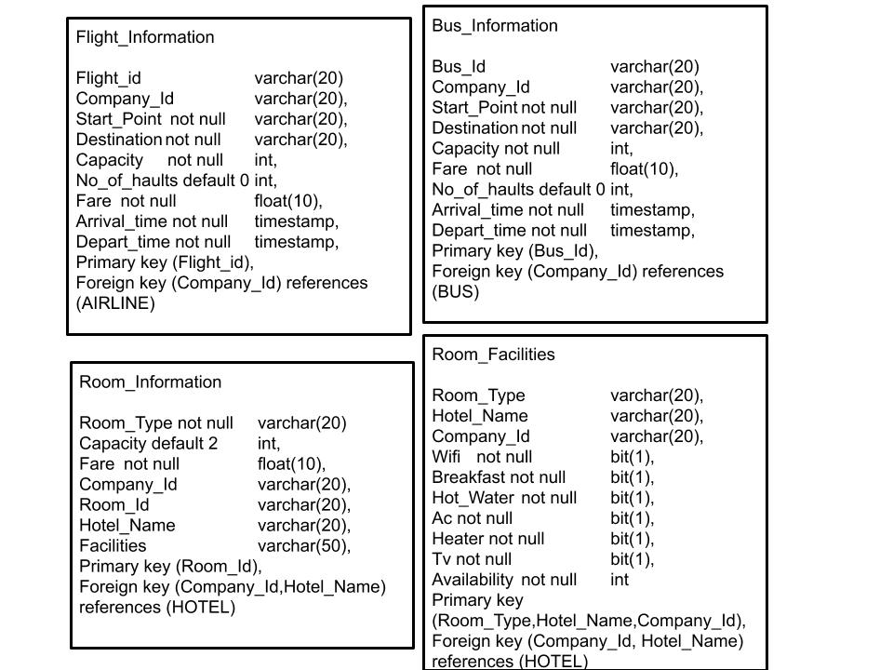

### Flight_Information

* Flight_id: A unique ID referring to a particular flight, **PRIMARY KEY**
* Company_Id: A unique ID referring to the Airline, **FOREIGN KEY**
* Start_Point: Starting location of the flight **NOT NULL**
* Destination: Destination of the flight **NOT NULL**
* Capacity: Stores the total capacity of the flight **NOT NULL**
* No_of_haults: Stores the number of halts **DEFAULT 0**
* Fare: Stores the price of the flight **NOT NULL**
* Arrival_time: The time of arrival of the flight **NOT NULL**
* Depart_time: The time of departure of the flight **NOT NULL**

### Bus_Information

* Bus_Id: A unique ID to refer to a particular bus, **PRIMARY KEY**
* Company_Id: A unique ID referring to the Bus **FOREIGN KEY**
* Start_Point: Starting location of the bus **NOT NULL**
* Destination: Destination of the bus **NOT NULL**
* Capacity: Stores the total capacity of the bus **NOT NULL**
* Fare: Stores the bus fare **NOT NULL**
* No_of_haults: Stores the number of halts **DEFAULT 0**
* Arrival_time: The time of arrival of the bus **NOT NULL**
* Depart_time: The time of departure of the bus **NOT NULL**

### Room_Information

* Room_Type: Stores the type of room **NOT NULL**
* Capacity: Stores room capacity **DEFAULT 2**
* Fare: Stores price of the room **NOT NULL**
* Company_Id: A unique ID referring to the hotel company, **FOREIGN KEY**
* Room_Id: A unique ID to refer to a particular room, **PRIMARY KEY**
* Hotel_Name: Name of the hotel, **FOREIGN KEY**
* Facilities: Stores various facilities the hotel provides

### Room_Facilities

* Room_Type: Stores the type of room, **PRIMARY KEY**
* Hotel_Name: Name of the hotel, **FOREIGN KEY , PRIMARY KEY**
* Company_Id: A unique ID referring to the hotel company, **FOREIGN KEY , PRIMARY KEY**
* Wifi: Binary value for whether or not the facility is provided **NOT NULL**
* Breakfast: Binary value for whether or not the facility is provided **NOT NULL**
* Hot_Water: Binary value for whether or not the facility is provided **NOT NULL**
* Ac: Binary value for whether or not the facility is provided **NOT NULL**
* Heater: Binary value for whether or not the facility is provided **NOT NULL**
* Tv: Binary value for whether or not the facility is provided **NOT NULL**
* Availability: Number of such type of rooms that are available **NOT NULL**

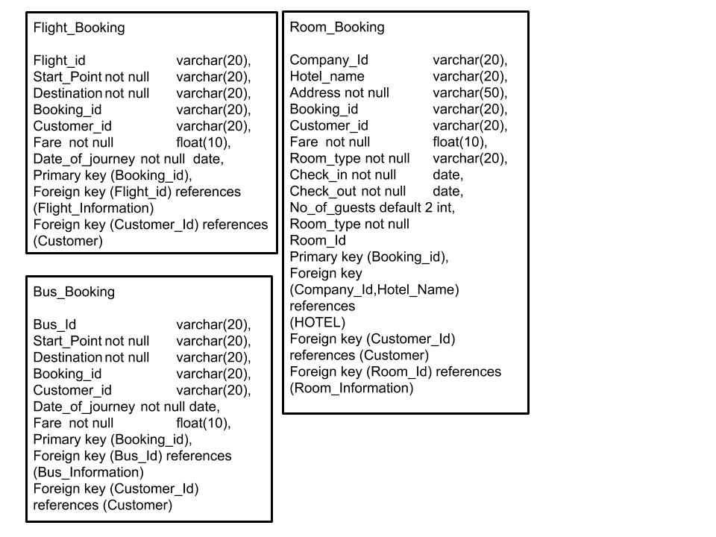

### Flight_Booking:

* Flight_Id: A unique ID to refer to a particular flight, **FOREIGN KEY**
* Start_Point: The starting point of the flight **NOT NULL**
* Destination: The final destination of the flight **NOT NULL**
* Booking_id: a unique ID referring to a particular booking, **PRIMARY KEY**
* Customer_id: a unique ID to refer to a particular customer, **FOREIGN KEY**
* Fare: Cost of the flight **NOT NULL**
* Date_of_journey: The date of the flight **NOT NULL**

### Bus_Booking:

* Bus_Id: A unique ID to refer to a particular bus, **FOREIGN KEY**
* Start_Point: The starting point of the bus **NOT NULL**
* Destination: The final destination of the bus **NOT NULL**
* Booking_id: a unique ID referring to a particular booking, **PRIMARY KEY**
* Customer_id: a unique ID to refer to a particular customer, **FOREIGN KEY**
* Fare: Cost of the bus booking **NOT NULL**
* Date_of_journey: The date of traveling **NOT NULL**

### Room_Booking:

* Company_Id: A unique ID referring to the hotel company, **FOREIGN KEY**
* Hotel_name: Stores the name of the hotel, **FOREIGN KEY**
* Address: Stores the location of the hotel **NOT NULL**
* Booking_id: a unique ID referring to a particular booking, **PRIMARY KEY**
* Customer_id: a unique ID to refer to a particular customer, **FOREIGN KEY**
* Fare: Cost of the room booking **NOT NULL**
* Check_in: Check-in date **NOT NULL**
* Check_out: Check out date **NOT NULL**
* No_of_guests: Stores the number of guests **DEFAULT 2**
* Room_Type: The type of room that has been booked **NOT NULL**
* Room_Id: referring to a particular room **FOREIGN KEY**

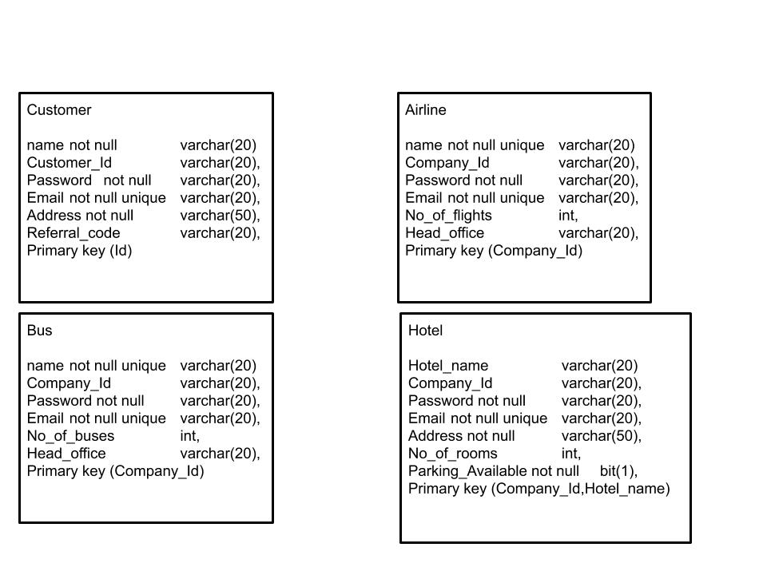

### CUSTOMER:

* Name: Stores the full name of the customer **NOT NULL**
* Id: Stores the id of the customer, **PRIMARY KEY**
* Password: Stores the password to the customers account for later authentication **NOT NULL**
* Email: Stores the email ID of the customer **NOT NULL UNIQUE**
* Address: Stores the address of the customer **NOT NULL**
* Referral_code: Stores the referral code that the customer can share with acquaintances to get discounts.

### AIRLINE

* Name: Stores the name of the airline **NOT NULL UNIQUE**
* Company_Id: Stores a unique id to refer to the company, **PRIMARY KEY**
* Password: Stores the password for the company that can be used by company officials to update details **NOT NULL**
* Email: Email id of the company **NOT NULL UNIQUE**
* No_of_flights: Stores the number of flights under the company
* Head_office: Head office location

### BUS

* name: Stores the name of the bus service **NOT NULL UNIQUE**
* Company_Id: Stores a unique id to refer to the bus company, **PRIMARY KEY**
* Password: Stores the password for the company that can be used by company officials to update details **NOT NULL**
* Email: Email id of the company **NOT NULL UNIQUE**
* No_of_buses: Stores the number of buses under the company
* Head_office: Head office location

### HOTEL

* Name: stores the name of the hotel, **PRIMARY KEY**
* Company_Id: Stores a unique id to refer to the hotel company, **PRIMARY KEY**
* Password: Stores the password for the company that can be used by company officials to update details **NOT NULL**
* Email: Email id of the company **NOT NULL UNIQUE**
* Address: Stores the location of the hotel **NOT NULL**
* No_of_rooms: Stores the number of rooms available
* Parking_Available: Keeps track of the parking availability **NOT NULL**

## Relationship between Data Entities

